Euclid’s Article

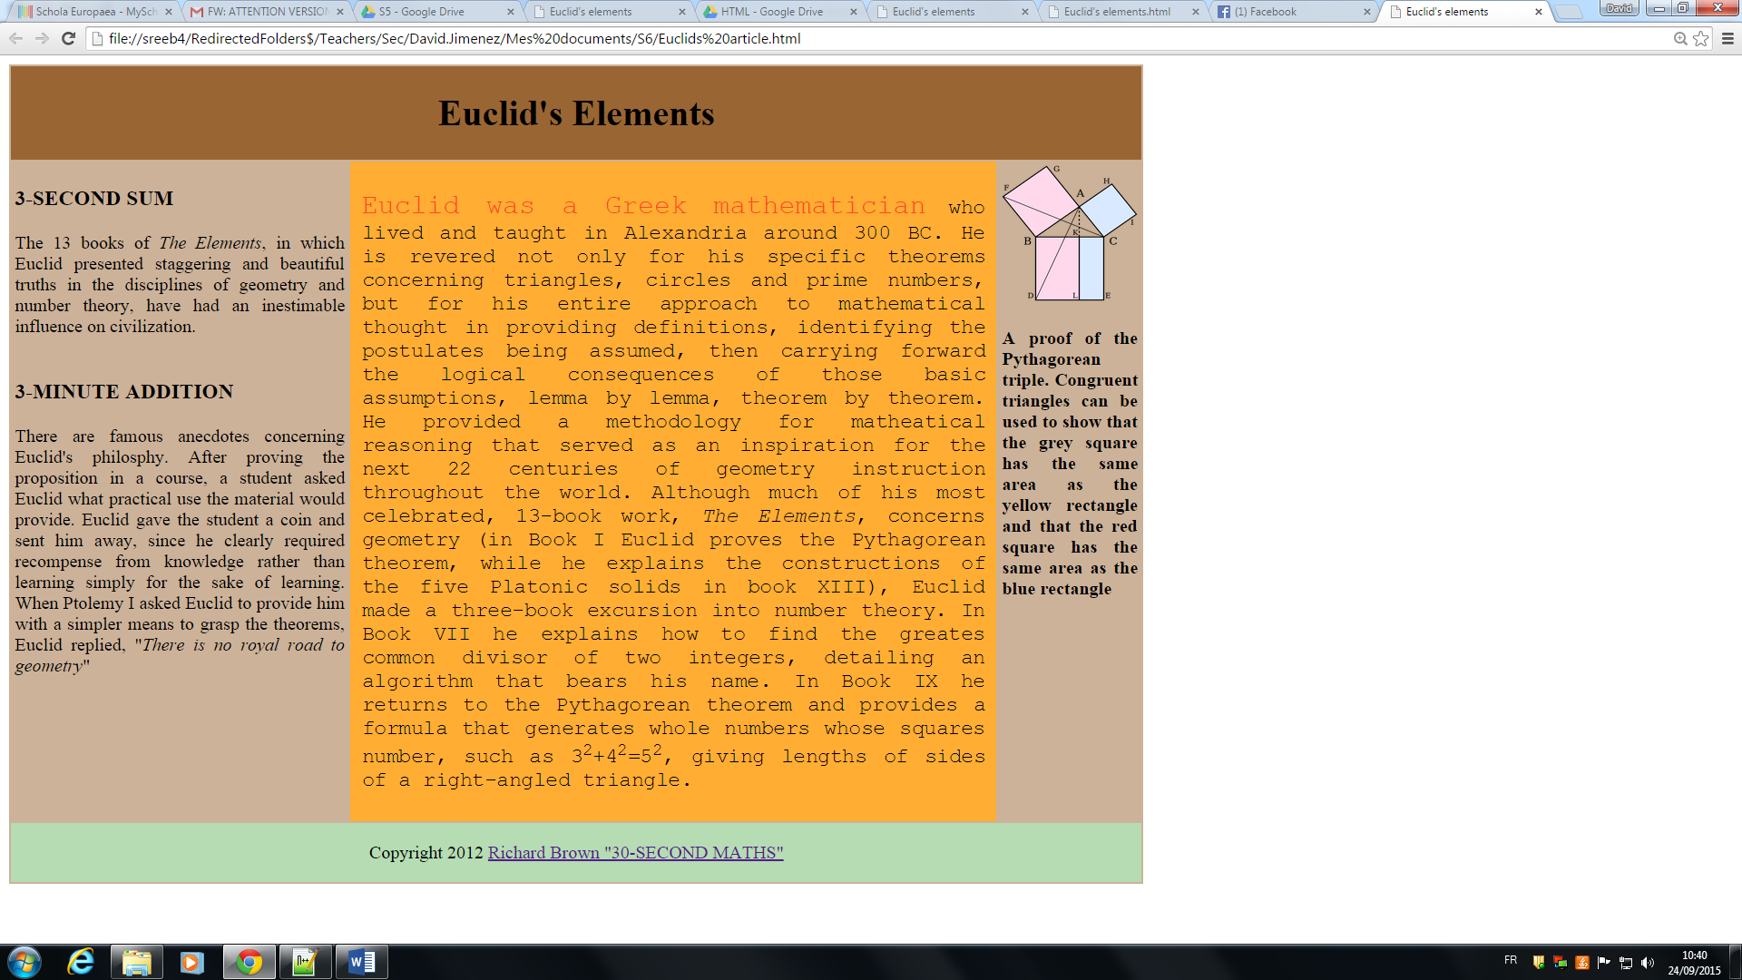

Above this lines you can see an Euclid’s Elements article. Save the exercise as “Euclid_article.html” into your folder

Characteristics for this website:

The main Layout is a table with width="1000px", no border and background color #CCB299. It is made up by three raws:

1st raw-title: colour #996633 with the text centered (merged cells).

2nd raw: it is subdivided in 3 different parts

1. Left part: table with colour #CCB299 width="30%" height="200". The headings are h3 and the text is justified.
2. Center part-main article: colour #FFAD33 and padding 10px (style="padding:10px"). The text is justified and the font is Courier and size 4; the first line has size 5 and colour #FF4724. Check the text because you have to give format to some text (emphasize, superscript,…) BC is an abbreviation of ‘Before Christ’.
3. Right part: table with colour the same colour as the left part but the text is bold. Link for the image (width and height are 120px): <http://upload.wikimedia.org/wikipedia/commons/thumb/5/59/Illustration_to_Euclid's_proof_of_the_Pythagorean_theorem2.svg/2000px-Illustration_to_Euclid's_proof_of_the_Pythagorean_theorem2.svg.png>

3rd raw: colour #b5dcb3 with the text centered (merged cells).

Link: <http://www.amazon.com/30-Second-Maths-Richard-J-Brown/dp/1848313691>

Paragraphs:

The 13 books of The Elements, in which Euclid presented staggering and beautiful truths in the disciplines of geometry and number theory, have had an inestimable influence on civilization.

There are famous anecdotes concerning Euclid's philosphy. After proving the proposition in a course, a student asked Euclid what practical use the material would provide. Euclid gave the student a coin and sent him away, since he clearly required recompense from knowledge rather than learning simply for the sake of learning. When Ptolemy I asked Euclid to provide him with a simpler means to grasp the theorems, Euclid replied, There is no royal road to geometry

Euclid was a Greek mathematician who lived and taught in Alexandria around 300 BC. He is revered not only for his specific theorems concerning triangles, circles and prime numbers, but for his entire approach to mathematical thought in providing definitions, identifying the postulates being assumed, then carrying forward the logical consequences of those basic assumptions, lemma by lemma, theorem by theorem. He provided a methodology for mathematical reasoning that served as an inspiration for the next 22 centuries of geometry instruction throughout the world. Although much of his most celebrated, 13-book work, The Elements, concerns geometry (in Book I Euclid proves the Pythagorean theorem, while he explains the constructions of the five Platonic solids in book XIII), Euclid made a three-book excursion into number theory. In Book VII he explains how to find the greates common divisor of two integers, detailing an algorithm that bears his name. In Book IX he returns to the Pythagorean theorem and provides a formula that generates whole numbers whose squares number, such as 32+42=52, giving lengths of sides of a right-angled triangle.

**A proof of the Pythagorean triple. Congruent triangles can be used to show that the grey square has the same area as the yellow rectangle and that the red square has the same area as the blue rectangle**